**FPT ACADEMY INTERNATIONAL**



## FPT – APTECH COMPUTER EDUCATION

ASTRONOMY WORLD

|  |  |  |  |
| --- | --- | --- | --- |
| **Center Name** | | FPT – Aptech – HCM2  Address: 590 Cach Mang Thang Tam, District 3, Ho Chi Minh City | |
| **Instructor** |  | Mr. Nguyen Phat Tai |  |
| **Class** |  | T1.2011.M0 |  |
| **Group** |  | 1 |  |
| **Group members** | | **Name** | **Student ID** |
|  |  | Phạm Thiên Long | Student1285597 |
|  |  | Ngô Tùng Thạch | Student1288224 |
|  |  | Nguyễn Bá Triết | Student1286314 |
| **Duration** | Start date | 3th March 2021 |  |
| End date | 29th March 2021 |  |

**This is to certify that**

**Mr.:**

Pham Thien Long

Ngo Tung Thach

Nguyen Ba Triet

**has successfully designed & developed**

eProject: AstronomyWord website

**Submitted by:**

Pham Thien Long

**Date of issue: 29-Mar-2021**

**Authorized Signature: Long**



**TABLE OF CONTENTS**

FPT – APTECH COMPUTER EDUCATION 1

ACKNOWLEGMENT 4

SYNOSIS 4

PROBLEM DEFINITION 4

CUSTOMER'S REQUIREMENTS SPECIFICATIONS (CRS) 5

Business/Project Objective: 5

Hardware/ Software Requirements: 6

SCOPE OF THE WORK (IN BRIEF) 7

Architecture and design of the system 8

Diagram of the website 9

TASK SHEET REVIEW 1 10

# ACKNOWLEGMENT

On behalf of all the members of group 1, I would like to thank you all for the hard works, supports to make this eProject complete successfully. Especially, Mr. Nguyen Phat Tai, our teacher, he helped us a lot from the day that we started to study at FPT Aptech. With this eProject, he has guided us with his enthusiasm and rigorous, because of his guiding, we would be able to finish this project. Besides, I want to thank all the team member of group 1, each of the team members has been working continuously in 4 weeks in order to complete this project. The last but not least, we would like to say thank you to our family for always supporting us, creating the best conditions for us to focus on the project, and putting faith in the dreams we pursue.

# SYNOSIS

We want to create a website for young people to be more exposed to astronomy. For those who love the stars, planets and wonders of this galaxy. We have searched from many sources to be able to provide the most current and accurate information to everyone.

# PROBLEM DEFINITION

The Web site is to be created based on the following requirements.

1. The home page about the description/images about various planets should be provided. If user clicks on the same, navigational link must be available.
2. There should be categories providing details about big bang theory, evolution of earth etc
3. The site should also list and explain various planets available as well as details about them as
   1. When discovered
   2. Size
   3. Atmosphere there
   4. Distance from sun and earth
   5. Other available important details about them.
4. There should be information on constellations as what is it/how it is formed and various constellations.
5. There should also be a section on comet giving information related.
6. Also include a section which will provide details on various latest developments in the field of astronomy related to planets and stars.
7. List of Few top Observatories with details and location displayed using GeoLocation API (eg. GoogleMaps).
8. Also each link must be properly hyperlinked; images must be used wherever necessary.

# CUSTOMER'S REQUIREMENTS SPECIFICATIONS (CRS)

**Client: ASTRONOMY WORLD**

### Business/Project Objective:

This website aims to provide users with a healthy environment to learn about astronomy, to help users better understand the stars, planets and the greatness of the galaxy. The website is synthesized from accurate origin information to bring users the most accurate knowledge and information to improve on the extraterrestrial field. It is also a playground for those who love this field to exchange, exchange and learn from each other about issues they care about.

The website will provide information, descriptions, images, videos as well as geographical location to help users understand better. Details of locations using GeoLocation API (eg. GoogleMaps), feedback must be included.

The website is to be developed for the Windows Platform using HTML5, JavaScript and Geolocation. The site should work well in all leading browsers including Chrome, IE, Firefox etc.

**Input to the system:**

- Searching for names of planets, stars, events, ..etc

**Output from the system:**

* A menu that will categorize all the functions of the site.
* Display the list of available albums category wisely.
* Perform the search based on a particular: planets , stars , events ...etc.
* The site will provide informative / polite information about the issues you want to find out about
* The location of the observatories under Observatories-page.
* Besides the above requirements, the site should have look and feel as per the industry standards.

**Expected delivery date:** 29-March-2021.

**List of deliverables:**

* + - * Document Word.
      * User Guide.
      * Source code.

### Hardware/ Software Requirements:

* **For developer**

**Hardware**

* + Intel Pentium 4 processor or higher
  + 1 Gigabytes of RAM or higher

**Software**

* + Windows 7 OS or higher
  + Adobe Dreamweaver
  + Web browsers such as IE, Chrome or Firefox are supporting HTML5, CSS3 and Javascript.
* **For web users**

**Hardware**

* + Intel Pentium 4 processor or higher
  + 512 Megabytes of RAM or higher

**Software**

* + Windows XP OS or higher
  + Web browsers such as IE, Chrome or Firefox are supporting HTML5, CSS3 and Javascript.

# SCOPE OF THE WORK (IN BRIEF)

After a long and detailed discussion, our group has decided to create a website contain the following webpages:

1. ***Homepage***: Display information about Astronomy , an introduction about Astronomy World.
2. ***Planets , Stars*** : Display all information of planets and starts ( characteristics , size , …)
3. ***Events*** : Give information about ‘Blood-Moon ’, ‘Snow Moon’, ‘New Moon’ etc.
4. ***Achievments***: Display the information of the achievments of astronomy today .
5. ***Observatories***: Display the address of the Observatories , allow customers to request any information they want from Astronomy World.

# Architecture and design of the system

Webpage request

**bootstrap**



Requested Page

**RENDERING**

**ENGINE**

**CSS CODE**

**HTML CODE**

**WEB SERVER**

**WEB BROWSER**

**CLIENT**

**SERVER**

# Diagram of the website

.

HOME

PLANETS

STARS

EVENTS

OBSERVATORIES

ACHIEVMENTS



# TASK SHEET REVIEW 1

|  |  |  |  |  |  |  |  |
| --- | --- | --- | --- | --- | --- | --- | --- |
| **Project Ref. No.:**  **eP/Advertisement Portal Management**  **System/01** | | **Project Title:** | **Activity Plan Prepared By:** | **Date of Preparation of Activity Plan:** | | | |
| **Sr.**  **No.** | **Task** | **Actual**  **Start Date** | **Actual Days** | **Team**  **Mate Names** | **Status** |
| 1 | Problem Statement | Astronomy World | Long | 3-March-21 | 1 | Long | Completed |
| 2 | Analysis of Astronomy World requirements about the website | 3-March-21 | 1 | Long | Completed |
| 3 | The scope of the work (in brief) | 3-March-21 | 1 | Thach | Completed |
| 4 | Architecture and design of the system | 3-March-21 | 1 | Thach | Completed |
| 5 | Diagram of the website | 3-March-21 | 1 | Triet | Completed |
| 6 | Task Sheet | 3-March-21 | 1 | Triet | Completed |

|  |  |
| --- | --- |
| **Date:** | |
| Signature of Instructor:  **Mr. Nguyen Phat Tai** | Signature of Team Leader:  **Mr. Pham Thien Long** |

# SITE MAP

EVENTS PAGE

EVENTS

STARS PAGE

STARS

PLANETS PAGE

PLANETS

HOME PAGE

ACHIEVMENTS

Observatories

ACHIEVMENTS PAGE

Observatories PAGE

# MOCK OF THE WEBSITE

1. **Homepage**

HEADER

(Navigation bar )

PLANETS

STARS

OBSERVATORIES

EVENTS

ACHIEVMENTS

FOOTER

1. **Planets Page**

HEADER

(Navigation bar )

Introduce

Characteristics and Structure

Videos , Images of Planets

FOOTER

1. **Stars Page**

HEADER

(Navigation bar )

Introduce

Characteristics and Structure

Videos , Images of Stars

FOOTER

1. **Achievments Page**

HEADER

(Navigation bar )

List of Achievments

FOOTER

Specical people in astronomy

1. **Obvervatories Page**

HEADER

(Navigation bar )

List of Obvervatories

FOOTER

Location , Information of Obvertories

1. **Events Page**

HEADER

(Navigation bar )

List of some Special Events of Astronomy

Information about event

Images , Video

FOOTER

# TASK SHEET REVIEW 2

|  |  |  |  |  |  |  |  |
| --- | --- | --- | --- | --- | --- | --- | --- |
| **Project Ref. No.:**  **eP/Advertisement**  **Portal Management System/01** | | **Project Title:** | **Activity Plan Prepared By:** | **Date of Preparation of Activity Plan:** | | | |
| **Sr.**  **No.** | **Task** | **Actual Start Date** | **Actual Days** | **Team Mate Names** | **Status** |
| 1 | Site map | Astronomy | Long | 10-Oct-20 | 1 | Thach | Completed |
| 2 | Mock of the website | 10-Oct-20 | 2 | Long | Completed |
| 3 | Task sheet | 10-Oct-20 | 2 | Thach | Completed |

|  |  |
| --- | --- |
| **Date:** | |
| Signature of Instructor:  **Ms. Nguyen Phat Tai** | Signature of Team Leader:  **Mr. Pham Thien Long** |

**WEBSITE DESCRIPTION**

1. Homepage

* Description:

Home page displays following information:

* + - * Observatories
* Screenshot :

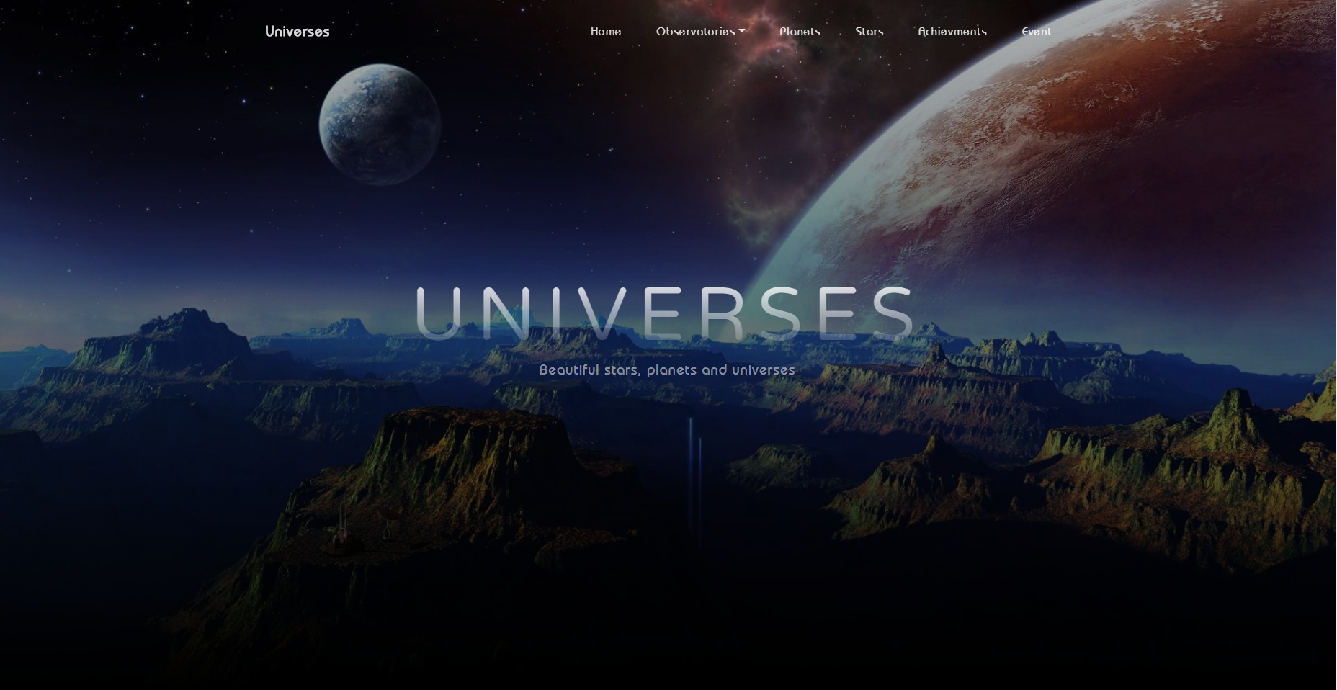

* + - * Observatories

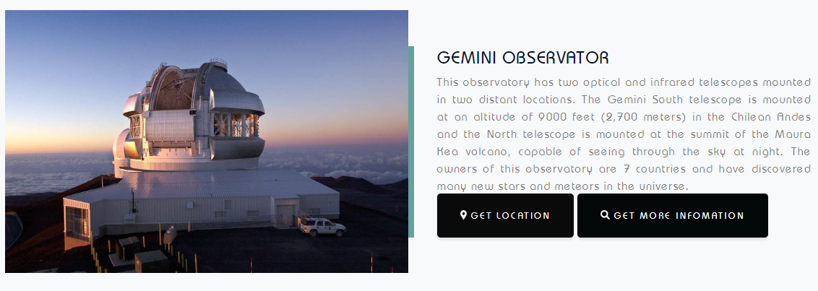

* 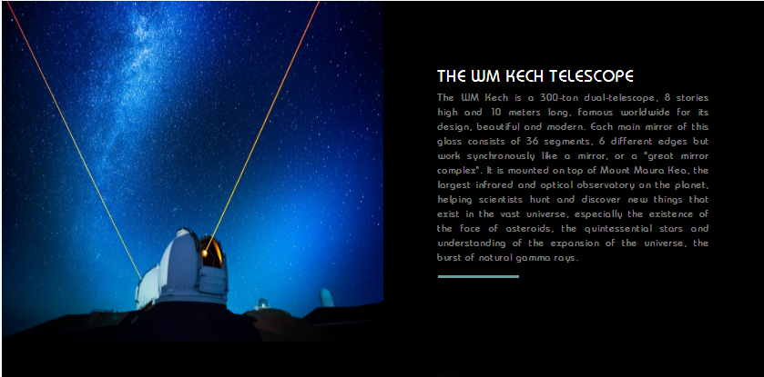THE WM KECH TELESCOPE
* THE HUBBLE TELESCOPE

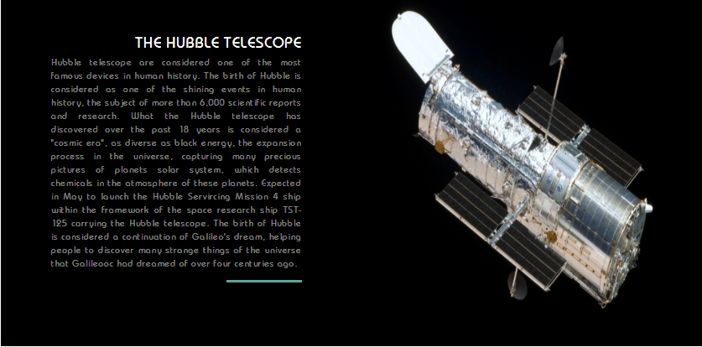

* 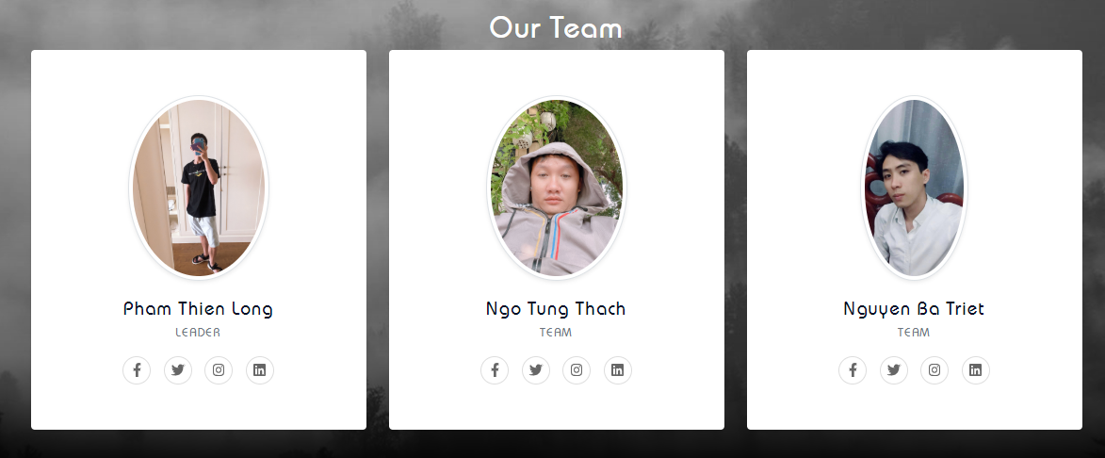Our Team
* Footer

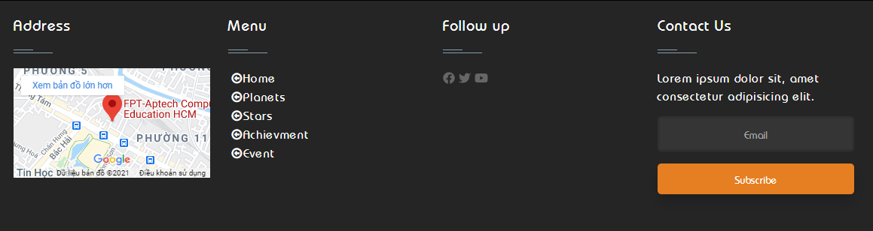

2.Planets

* Description:
  + - * Giới thieu day la gi
* Screen shot: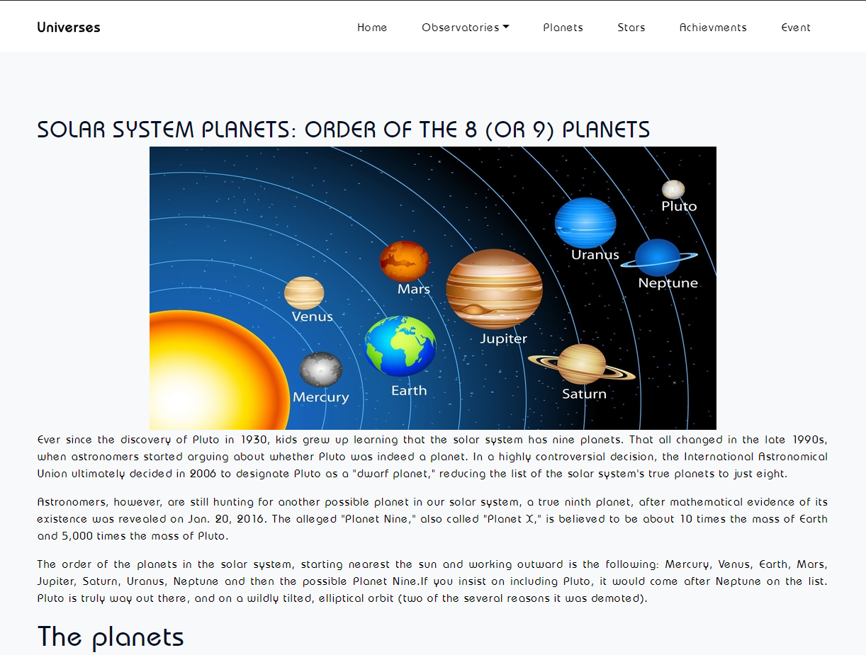

3.Stars

* Description:
  + - * Giới thieu day la gi
* 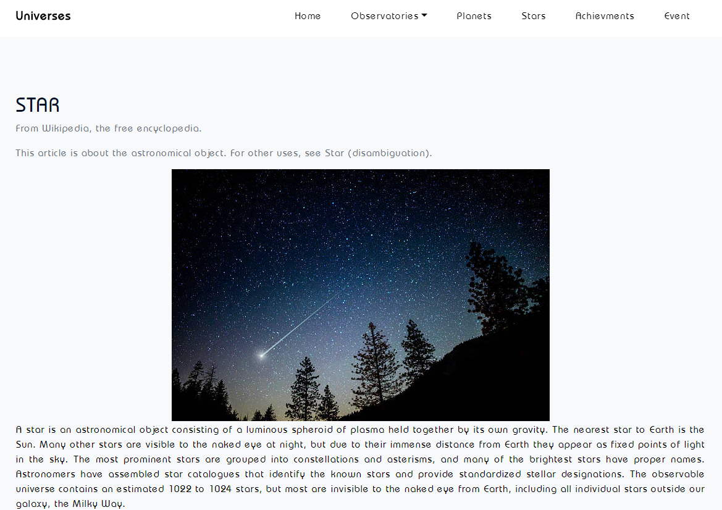Screen shot:

4.Achievment

* Description:
  + - * Giới thieu day la gi
* Screen shot:

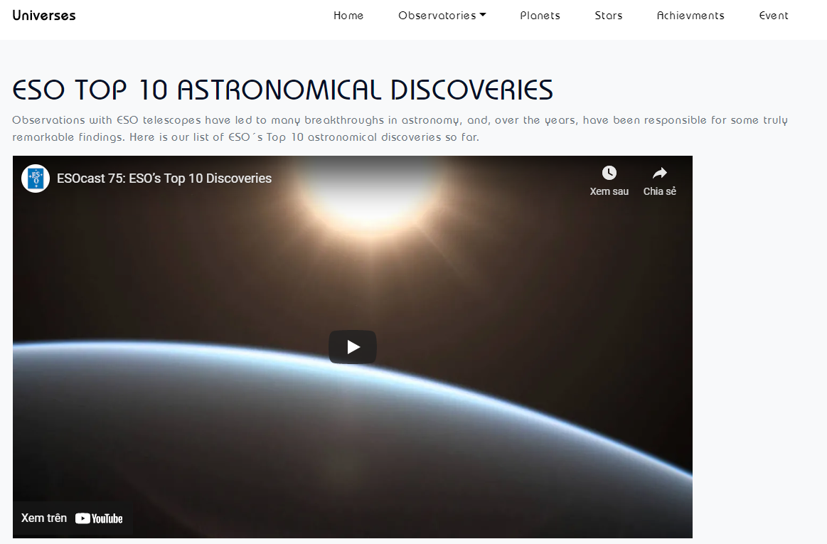

5.Event

* Description:
  + - * Giới thieu day la gi
* Screen shot:

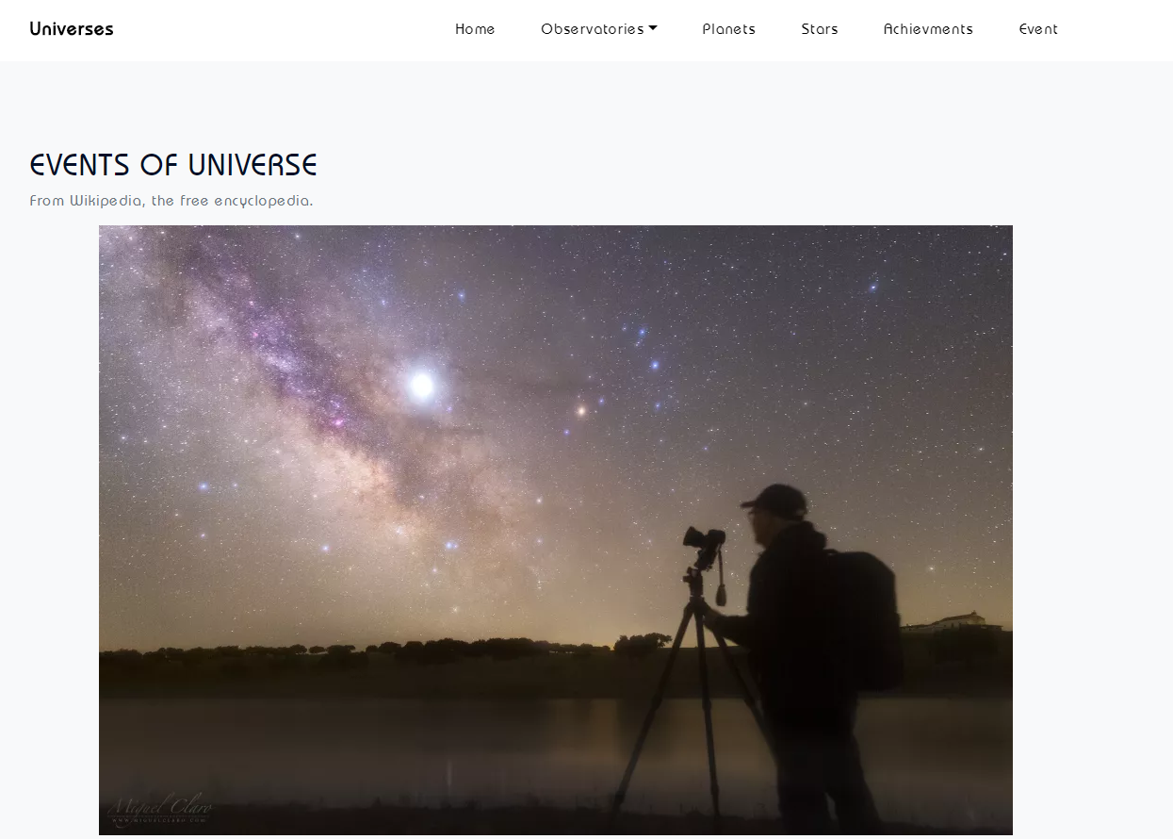

**HTML, CSS, BOOTSTRAP DESCRIPTION**

* **This html and bootstrap to create the header for the home page navbar:**

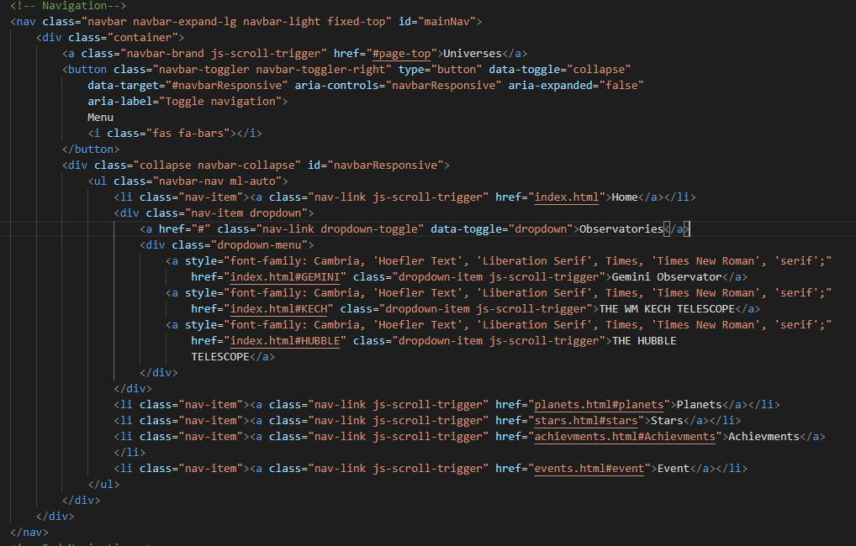  
  
**Planets :**

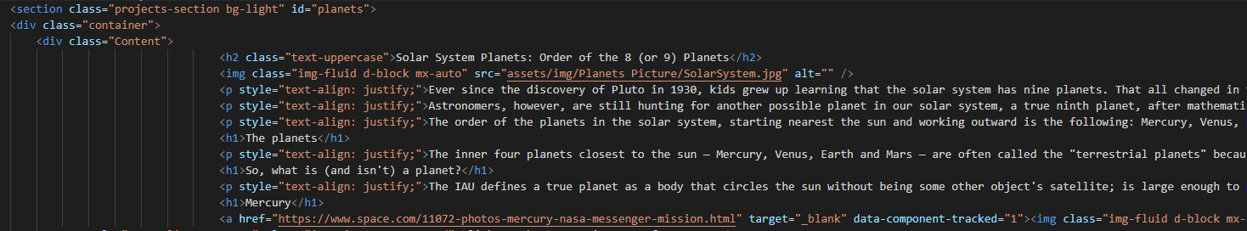

**Stars :**

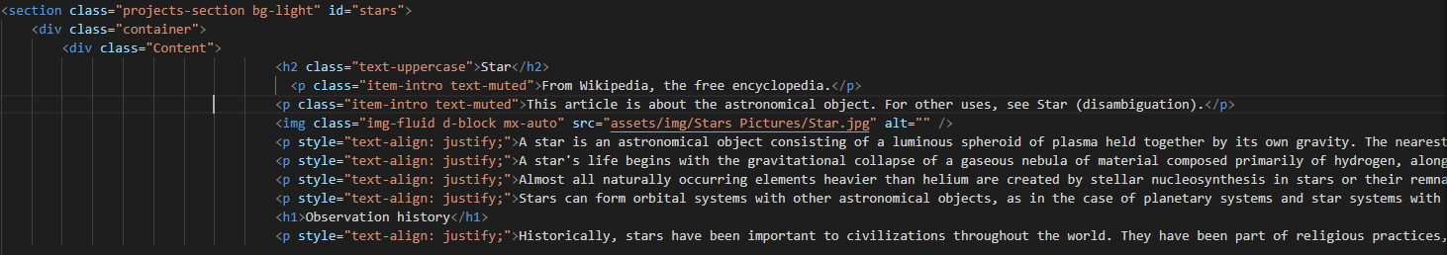  
  
**Bchievments:**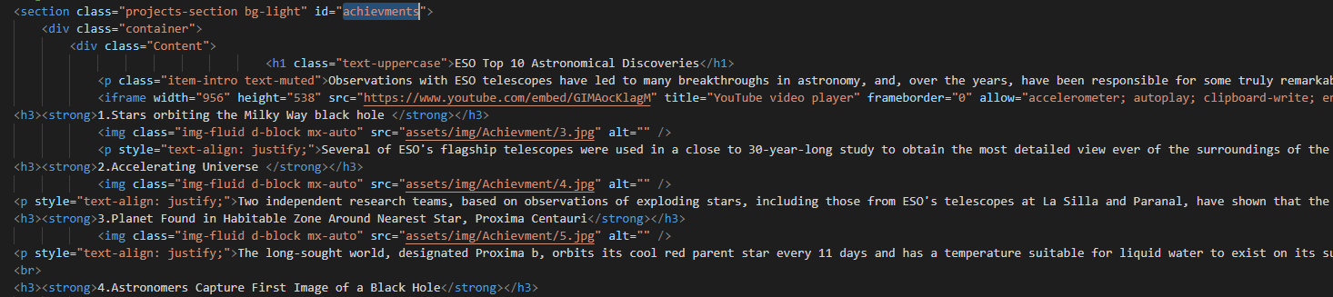

**Event:**

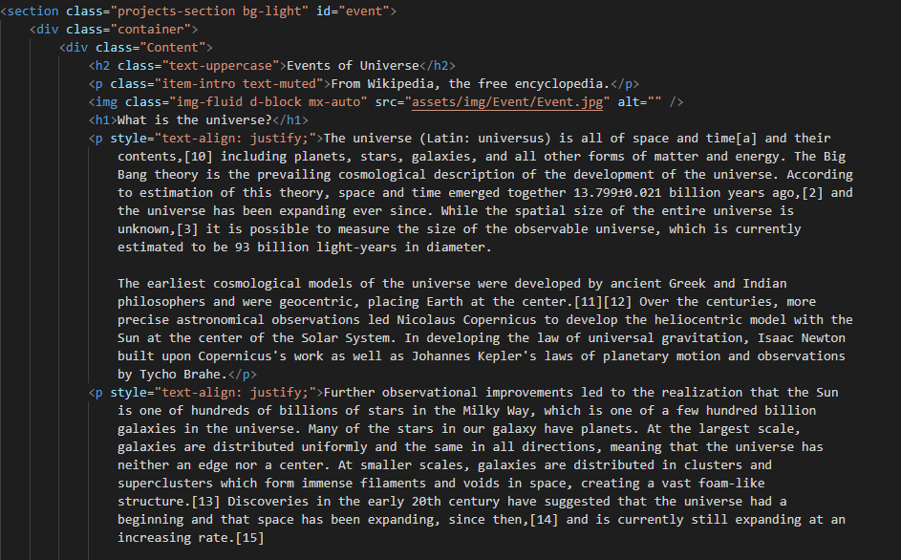

* **This css to create style for the Footer:**

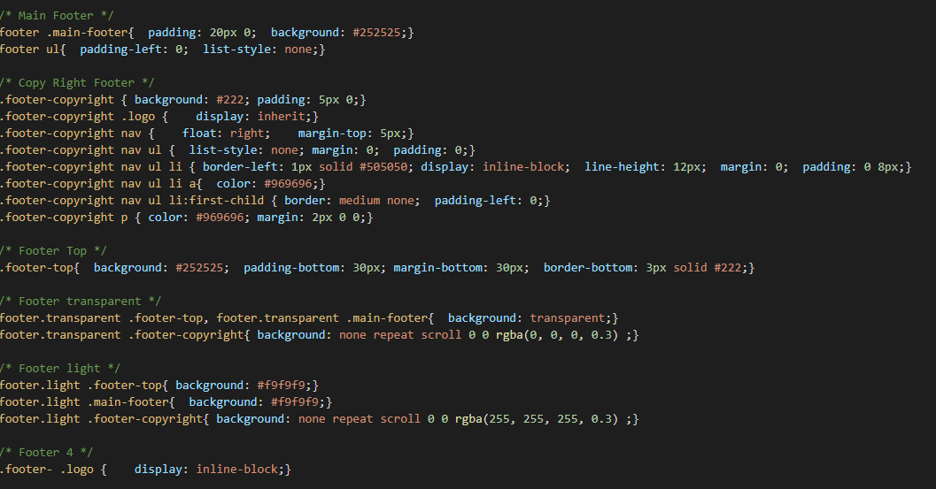

# TASK SHEET REVIEW 3

|  |  |  |  |  |  |  |  |
| --- | --- | --- | --- | --- | --- | --- | --- |
| ***Project Ref. No.:***  ***eP/Advertisement Portal Management System/01*** | | ***Project Title:*** | ***Activity Plan Prepared By:*** | ***Date of Preparation of Activity Plan:*** | | | |
| ***Sr.***  ***No.*** | ***Task*** | ***Actual Start***  ***Date*** | ***Actual Days*** | ***Team Mate***  ***Names*** | ***Status*** |
| *1* | *Home page (navigation bar)* | Astronomy | **Long** | 23-Mar-21 | *1* | *Thach* | *Completed* |
| *2* | *Planets* | 23-Mar-21 | *1* | *Long* | *Completed* |
| *3* | *Stars* | 23-Mar-21 | *1* | *Triet* | *Completed* |
| *4* | *Achievments* | 23-Mar-21 | *1* | *Long* | *Completed* |
| *5* | *Event* | 23-Mar-21 | *1* | *Triet* | *Completed* |
| *6* | *Css Footer* | 23-Mar-21 | *1* | *Thach* | *Completed* |

|  |  |
| --- | --- |
| **Date: 26/3/2021** | |
| Signature of Instructor:  **Mr. Nguyen Phat Tai** | Signature of Team Leader:  **Mr. Pham Thien Long** |